Ch04-Lab4-2 Microsoft Visual C++

Creating an Empty Application

- Start Visual Studio and Click on Create A New Project
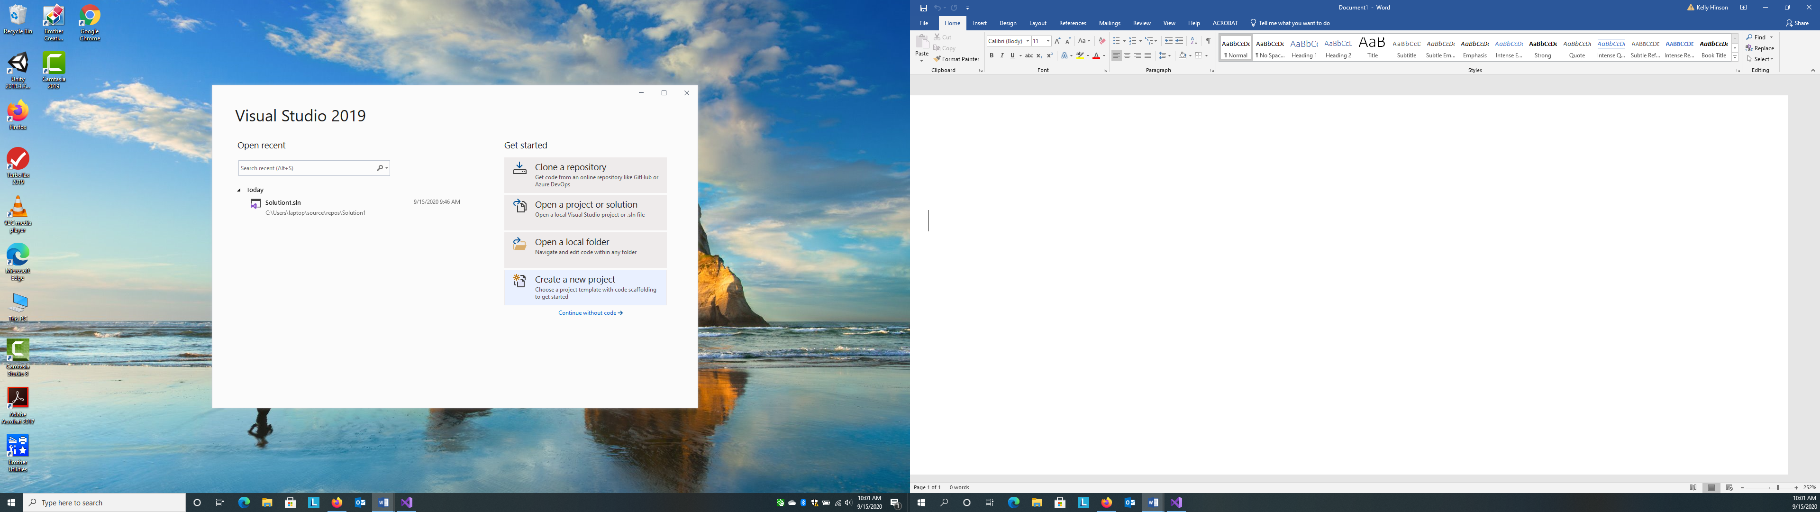

- Change the third drop-down box to All Project Types. Then, Select Empty Project.
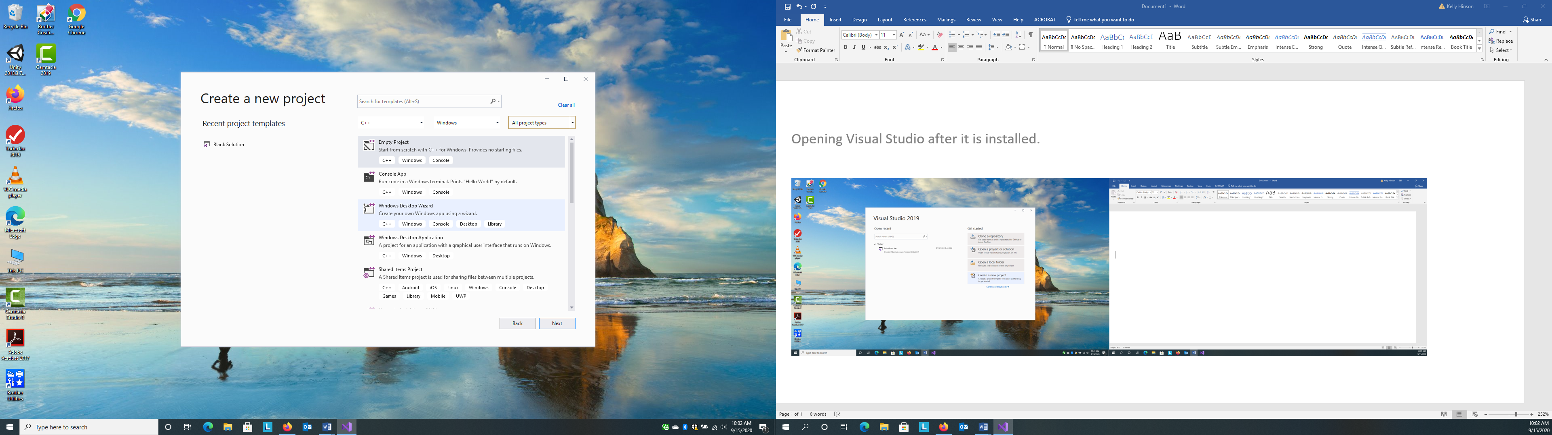

- Name your project and then CREATE.
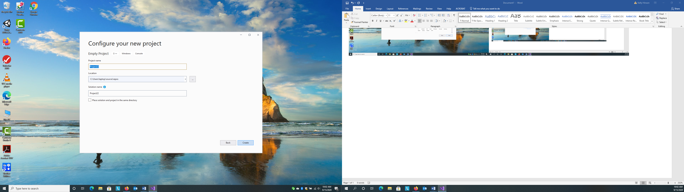
- Right click Source, Add, New Item.

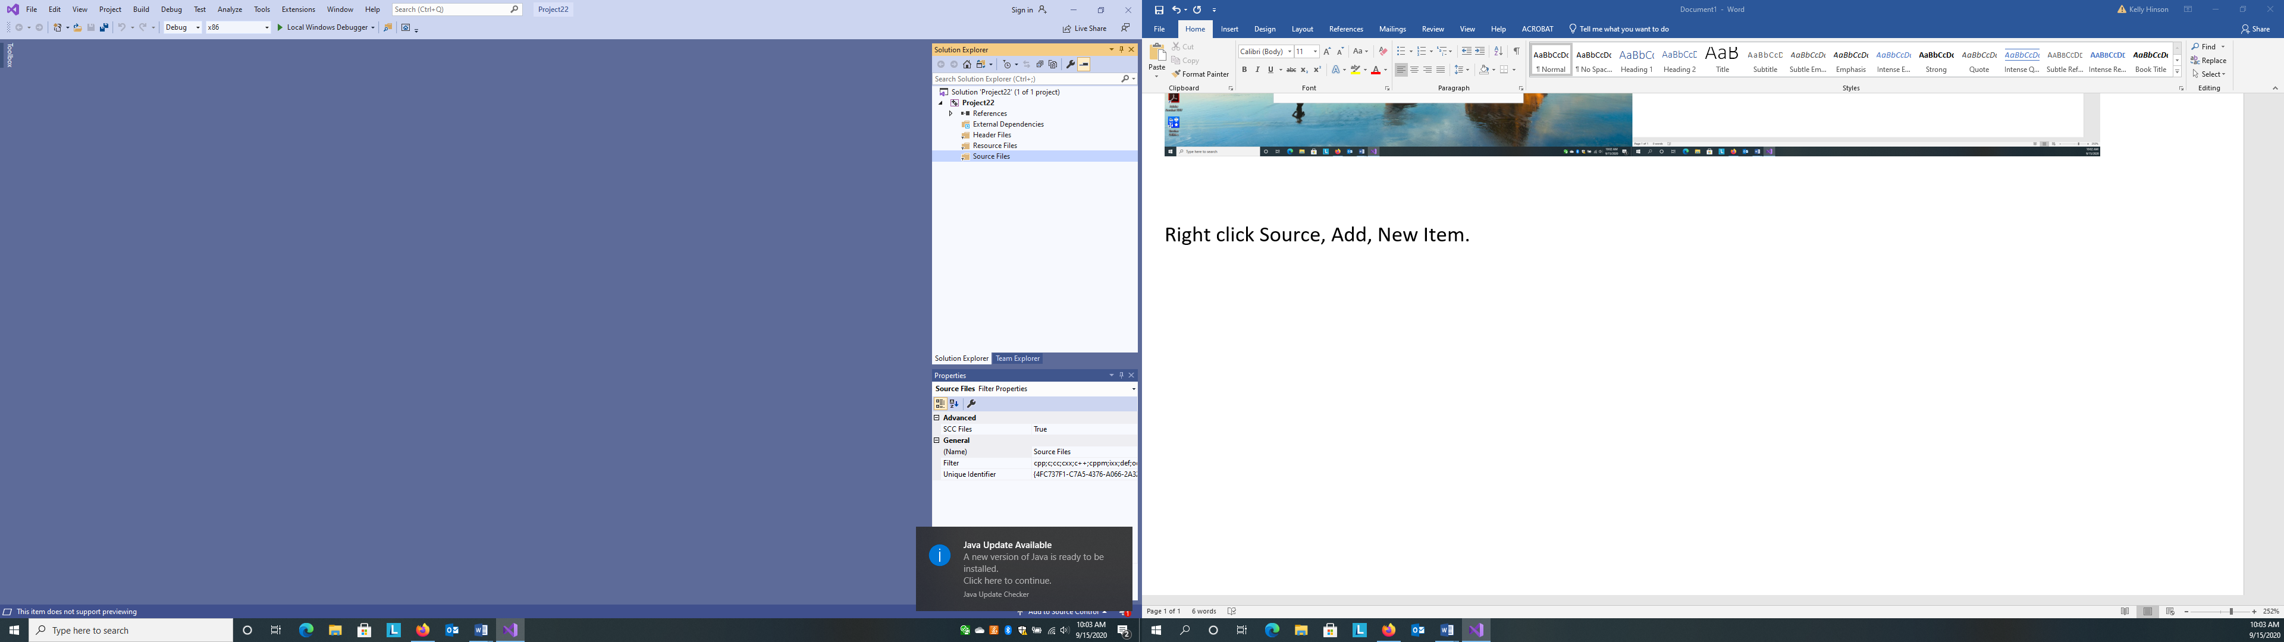

- Click C++ File. Enter a name, click ADD, and the screen will then let you start entering your C++ code.
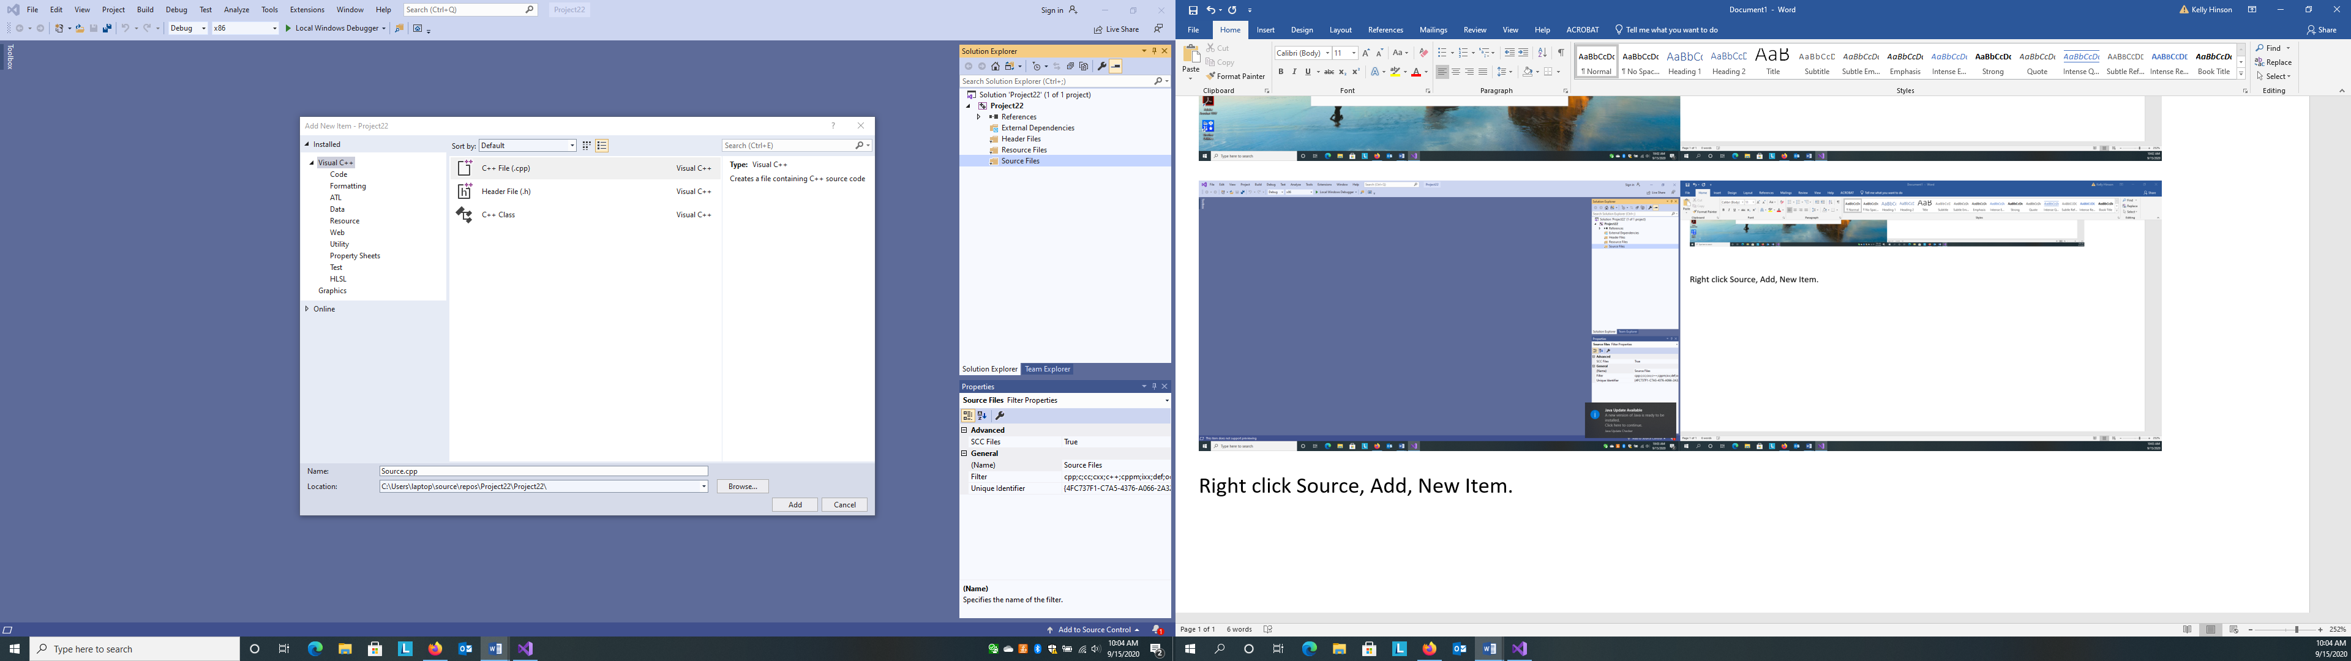

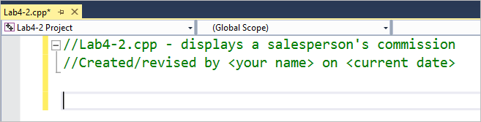
- Enter the comments shown in Figure 9, replacing <your name> and <current date> with your name and the current date, respectively. Press Enter twice after typing the second comment. The asterisk on the tab indicates that the changes made to the Lab4-2.cpp file have not been saved.
indicates that the file was changed since the last time it was saved

Figure 9 Comments entered in the Lab4-2.cpp source file

- Next, enter the following directives. Be sure to use the exact capitalization and punctuation shown here. Press Enter twice after typing the second directive.

#include <iostream> using namespace std;
- Now you will begin entering the main function. Type int main() and press Enter, and then type { (the opening brace) and press Enter. The Text Editor automatically provides the closing brace (}).
- Click immediately after } (the closing brace), press Tab, type //end of main function and then press Enter.
- Click the blank line above the closing brace. If necessary, press Tab to position the insertion point above the
- //end of main function comment. Enter the following comment and declaration statements. Press
- Enter twice after typing the last declaration statement.

//declare named constant and variables const double COMM_RATE = 0.1; double sales = 0.0;
double commission = 0.0;
- Next, get the sales amount from user. Enter the following comment and statements. Press Enter twice after typing the last statement.

//enter input item
cout << "Sales amount: ";
cin >> sales;
- Now calculate and display the commission. Enter the following comment and statements. Press Enter twice after typing the last statement.

//calculate and display the commission commission = sales * COMM_RATE; cout << "Commission: $ " << commission << endl;
system(“pause”); //this statement pauses the program so that the user can see the answer on the screen
- Finally, you will enter the return statement. Type return 0; and then click the blank line above the statement.
- Click File on the menu bar and then click Save All. (Or, you can click the Save All button on the Standard toolbar.) Figure 10 shows the program instructions entered in the Lab4-2.cpp source file.

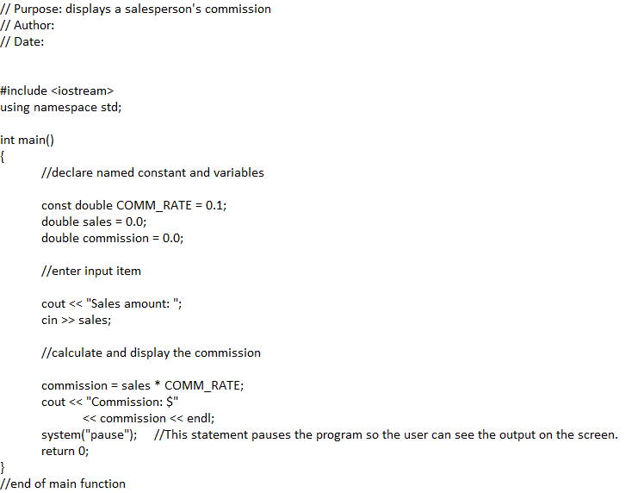
Figure 10 Program instructions entered in the Lab4-2.cpp source file
- Before running a saved program, you need to build it. Building a C++ program involves compiling the source code into object code and then invoking the linker program to link the object code to other machine code necessary for your C++ program to run. Click Build on the menu bar, and then click Build Solution. If your program does not contain any errors, the “Build succeeded” message appears in the lower-left corner of the Output window. In addition, the Output window displays the message “Build: 1 succeeded, 0 failed, 0 up-to- date, 0 skipped”. The messages indicate that the program was built (compiled and linked) successfully. See Figure 11. (If your program contains errors, carefully compare your instructions with the ones shown in Figure
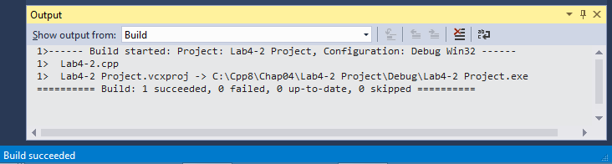
Figure 11 Status messages shown in the Output window
- Now you can run (start) the program. Click Debug on the menu bar and then click Start Without Debugging. If your Debug menu does not contain the Start Without Debugging option, press Ctrl+F5. (If you want to add the Start Without Debugging option to the Debug menu, refer to the Important Notes section at the end of this document.) The Start Without Debugging option (or Ctrl+F5) tells the computer to run the Lab4-2.exe file contained in the Cpp8\Chap04\Lab4-2 Project\Debug folder. The .exe file was created when the program was built successfully in Step 20. The “Sales amount:” prompt appears in the Command Prompt window, as shown in Figure 12.
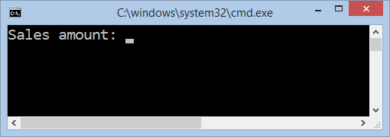
Figure 12 Message displayed in the Command Prompt window
- First, you will test the program using 1328.50 as the sales amount. Type 1328.50 and then press Enter. The Command Prompt window indicates that the commission is $132.85. See Figure 13.
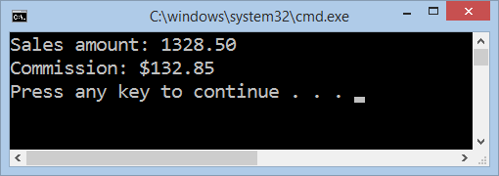
Figure 13 Commission displayed in the Command Prompt window
- Press Enter (or any key) to close the Command Prompt window.
- Now you will test the program using 267.90 as the sales amount. Because you did not make any changes to the program after compiling it, you can simply start (run) the program again. Either press Ctrl+F5 or click Debug and then click Start Without Debugging.
- You can change the appearance (for example, the font, size, colors, and so on) of the Command Prompt window. Right-click the window’s title bar and then clicking Properties. Click the Font tab. The Command Prompt windows in Figures 12 and 13 use the Consolas font and a size of 24 for the text. Select whichever font and size you prefer.
- Click the Colors tab. If necessary, click the Screen Text radio button, and then click the black square. Click the Screen Background radio button, and then click the white square. Click the OK button to close the Properties window.
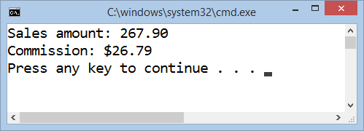
- Type 267.90 as the sales amount and then press Enter. See Figure 14.
Figure 14 Commission displayed in the customized Command Prompt window
- Press Enter (or any key) to close the Command Prompt window. Close the Output window by clicking the
Close button on its title bar.
- At times, it is helpful to display line numbers in the editor window. Click Tools on the menu bar, and then click Options to open the Options dialog box. Expand the Text Editor node (if necessary) and then click C/C++. Select the Line numbers check box. See Figure 15.
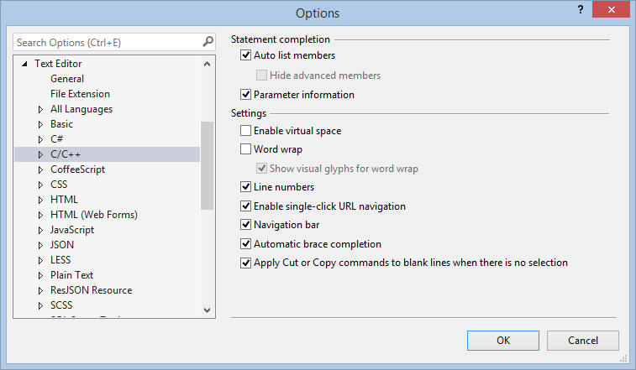
Figure 15 Options dialog box
- Click the OK button to close the Options dialog box. See Figure 16.
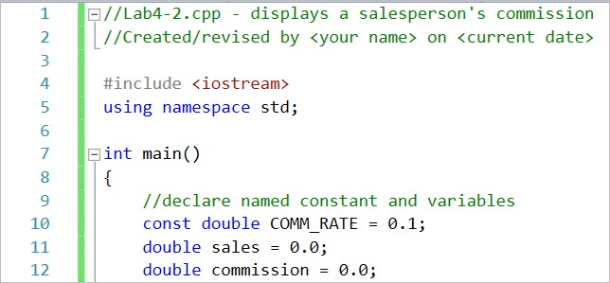
Figure 16 Some of the line numbers displayed in the editor window
- Click File on the menu bar, and then click Close Solution to close the Lab4-2 solution. Click the Solution Explorer tab to temporarily display the Solution Explorer window, which allows you to verify that the solution is closed.
- If you want to remove the line numbers from the editor window, click Tools on the menu bar, and then click Options. If necessary, expand the Text Editor node, and then click C/C++. Deselect the Line numbers check box, and then click the OK button.
- Click File on the menu bar and then click Exit to exit Visual Studio.

